**Call Data Record - Inter Operator Settlement**

**Scope**

This document specifies charging functionality and charging management for cellular service providers. Specifically, this document describes the handling of CDR files that contain CDR records. Each CDR record contains descriptions of charging events such as voice calls and SMS messages with all relevant data.

**Offline Charging**

Offline charging is a process where charging information for network resource usage is collected concurrently with that resource usage. The charging information is then passed through a chain of logical charging functions. At the end of this process, CDR files are generated by the network, which are then transferred to the network operator’s BD (Billing domain) for the purpose of subscriber billing and inter-operator accounting.

**CDR Flow Diagram**

The CDR files contain a header section followed by a variable sized CDR data section. The CDR data section contains zero or more concatenated CDR records. Each CDR record is encoded on a single line.

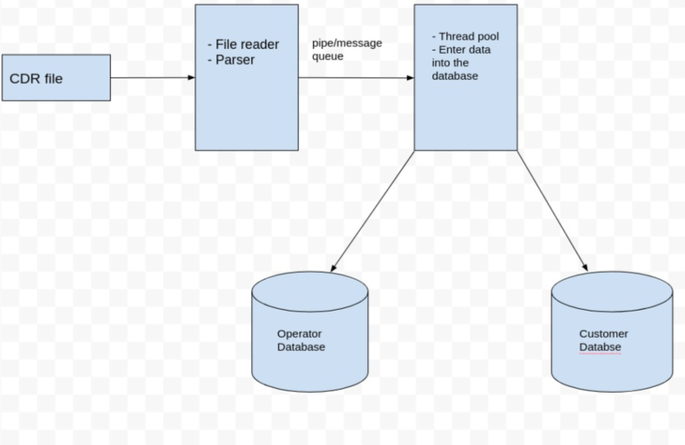

**Processing Functions**

The CDR files are usually large files (1-5 MB). Processor will read and process files in order to fulfil the following functions

1. **Functional Requirements**

**[CDR-IOS]/01 -** Directory able to access .CDR files.

**[CDR-IOS]/02 - MSISDN:**

Unique number identifying a subscription in a mobile network maximum length of an MSISDN to 7 digits.

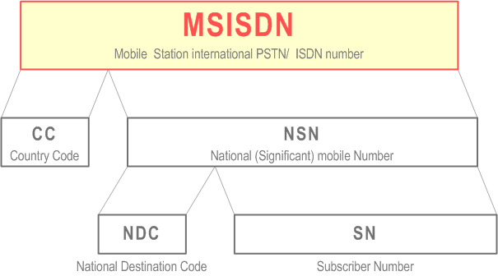

**[CDR-IOS]/03 - Brand Name:**

Subscriber Brand Name: a string maximum 64 chars. Such as “Airtel”.

**[CDR-IOS]/04 - MMC/MNC:**

Subscriber MMC/MNC: mobile country code and mobile network code maximum 6 digits.

**[CDR-IOS]/05 - MOC: Outgoing Voice Call**

* Inter Operator Settlement contains information about “Outgoing voice calls duration to a subscriber within the mobile operator.”

**Ex:** Airtel is the Mobile operator for the person who called and who receives that call. We have to note the duration of that outgoing call.

* Inter Operator Settlement contains information about “Outgoing voice calls duration to a subscriber outside the mobile operator.”

**Ex:** Airtel is the Mobile operator for the person who called and Idea is the Mobile operator who receives that call. We have to note the duration of that outgoing call.

**[CDR-IOS]/06 - MTC: Incoming Voice Call**

* Inter Operator Settlement contains information about “Incoming voice calls duration to a subscriber within the mobile operator.”

**Ex:** Airtel is the Mobile operator for the person who called and who receives that call. We have to note the duration of that incoming call.

* Inter Operator Settlement contains information about “Outgoing voice calls duration to a subscriber outside the mobile operator.”

**Ex:** Airtel is the Mobile operator for the person who called and Idea is the Mobile operator who receives that call. We have to note the duration of that incoming call.

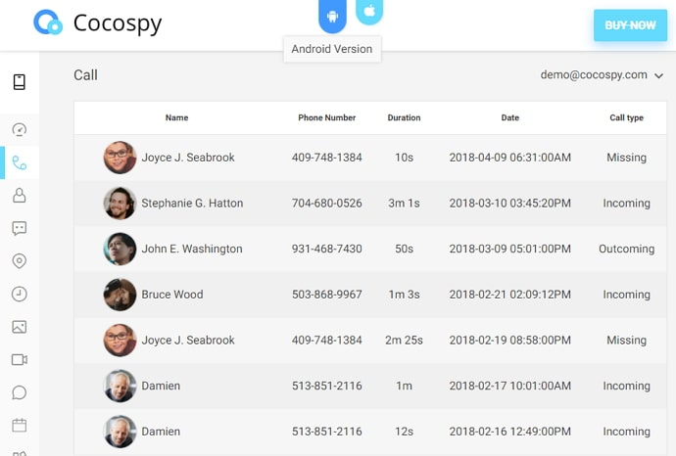

**[CDR-IOS]/07 - SMS-MO: Outgoing Message**

* Inter Operator Settlement contains information about “SMS messages sent within the mobile operator.”

**Ex:** Subscriber with Airtel mobile operator sent message to the the subscriber of Airtel mobile operator itself. We have to know the source and destination phone numbers.

* Inter Operator Settlement contains information about “SMS messages sent outside the mobile operator.”

**Ex:** Subscriber with Airtel mobile operator sent message to the the subscriber of BSNL mobile operator. We have to know the source and destination phone numbers.



**[CDR-IOS]/08 - SMS-MO: Incoming Message**

* Inter Operator Settlement contains information about “SMS messages received within the mobile operator.”

**Ex:** Subscriber with Airtel mobile operator receives message from the subscriber of Airtel mobile operator itself. We have to know the source and destination phone numbers.

* Inter Operator Settlement contains information about “SMS messages received outside the mobile operator.”

**Ex:** Subscriber with Airtel mobile operator receives message from the subscriber of BSNL mobile operator. We have to know the source and destination phone numbers.



**[CDR-IOS]/09 - Download: MB downloaded if call type is GPRS**

* Inter Operator Settlement contains information about “MB downloaded.”

**Ex:** If you have downloaded anything from browser, or received any files from any other sources, then we have to note that how much Internet had used to download those files.

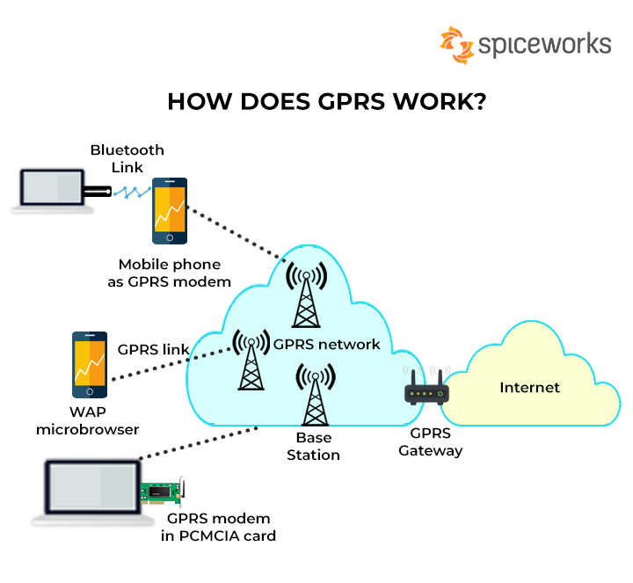

**[CDR-IOS]/10 - Upload: MB uploaded if type is GPRS**

* Inter Operator Settlement contains information about “MB uploaded.”

**Ex:** If you have uploaded anything to drive, or shared any files to any other sources like whatsapp or gmail, then we have to note that how much Internet had used to upload those files.

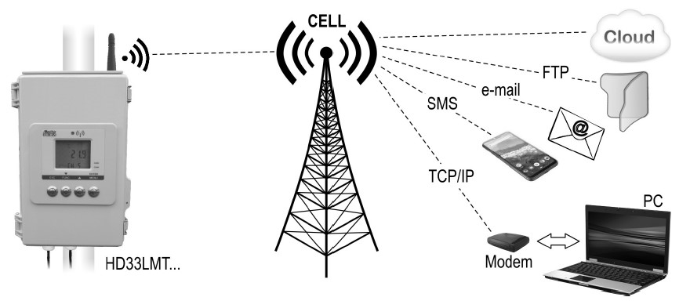

**[CDR-IOS]/11 - Third party MSISDN:**

* Corresponding third party in this call, empty for GPRS

**[CDR-IOS]/12 - Third party Subscriber MMC/MNC:**

* Corresponding third party’s mobile subscriber in this call.

**[CDR-IOS]/13 -** By using multi threading we have to print the aggregate information of incoming/outgoing voice calls/messages, MB uploaded and downloaded for same and different network provider /operators.

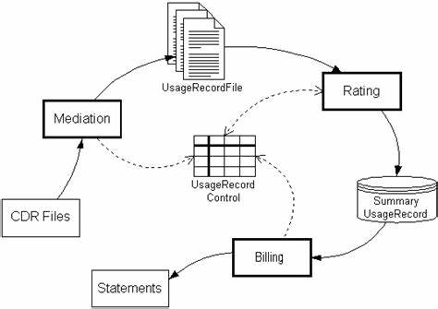

1. **Non-Functional Requirements**

## **2.1 Performance Requirements**

The mobile will require a fair network/signal connection to receive call/SMS or to transfer files and to make call/SMS or to receive files.

## **2.2 Safety Requirements**

Call recordings must be stored securely and businesses should ensure proper access controls are in place. There should be physical and technical safeguards for data security and privacy. You should assess the risks associated with hackers, malicious insiders, and even careless employees and take measures accordingly.

## **2.3 Security Requirements**

The Call Data Record itself does not provide authentication and security. We have to provide authentication to access this files. We have to secure the data in directory.

**Ex: Data.cdr**

1037928|Rami levi|42502|SMS-MT|0|0|0|1136404|42504

1513251|Rami levi|42502|MOC|135|0|0|1686214|42502

1215082|Rami levi|42502|MTC|116|0|0|1266690|42503

1497537|Partner|42501|SMS-MO|0|0|0|1879213|42501

1800253|Partner|42501|GPRS|0|0|337||42504

**Output**

Operator Brand: Rama levi (42502)

Incoming voice call durations:116

Outgoing voice call durations:135

Incoming Messages:1

Outgoing Messages:0

MB downloaded: 0 | MB uploaded: 0

Operator Brand: Partner (42501)

Incoming voice call durations:0

Outgoing voice call durations:0

Incoming Messages:0

Outgoing Messages:1

MB downloaded: 0 | MB uploaded: 337